# Lab 4-Linux Shell Scripting

## Tasks

Follow the instructions of your instructor and use the above concept of shell scripting complete the following.

* Write a script to write and then read a file and view it on screen using the parameters and input from user.

**Code:**

#!/bin/bash

echo "Enter name: "

read n

echo "Enter ID: "

read i_d

echo "Name: $n"

echo "ID: $i_d"

**Output:**

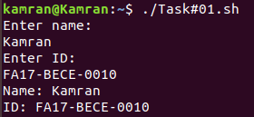

* Write 2 C program one prints “I love Operating System” and other prints “I love Linux”. Compile and Run both programs and print the output to two different files. After then combine both the files in one new file using a single command.

**Code:**

**Program#01:**

#include<stdio.h>

int main()

{

printf("I love operating system\n");

return 0;

}

**Program#02:**

#include<stdio.h>

int main()

{

printf("I love linux\n");

return 0;

}

**Output:**

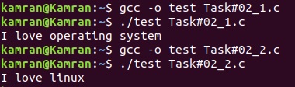

**Combined Output:**

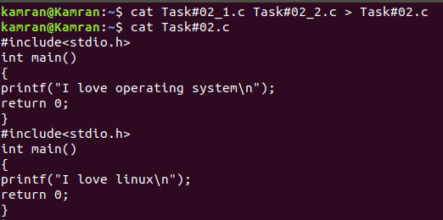

* Write scripts /commands / syntax to print a message “Welcome to the World of Shell Scripting”

**Code:**

#!/bin/bash

echo "Welcome to the world of shell scripting"

**Output:**



* Write scripts /commands / syntax to print user information who currently login, current date and time

**Code:**

#!/bin/bash

echo "---Login Information---"

name="$USER"

echo "Username: $name"

d=$(date)

echo "Current Date & Time: $d"

**Output:**

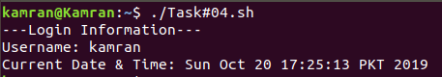

* Write scripts /commands / syntax to take input and print your name, degree program information, batch No and course title

**Code:**

#!/bin/bash

echo "Enter name: "

read n

echo "Enter degree program: "

read dp

echo "Enter batch no: "

read bn

echo "Enter course title: "

read ct

echo -e "\nName: $n"

echo "Degree Program: $dp"

echo "Batch No: $bn"

echo "Course Title: $ct"

**Output:**

